History of the AHFJC Healing Funds

Gordon Goichi Nakayama was an Anglican Church of Canada priest from the 1930s to the 1990s. During his ministry, he sexually abused approximately 300 boys.

In 2015, the Anglican Church of Canada publicly apologized to the Japanese Canadian community, and committed to meaningful follow-up.

The Anglican Healing Fund for Japanese Canadians—AHFJC—was established in 2021 with $610,000 in funding from the Anglican Church. Funds provide confidential informational and mental health support for survivors and survivor families of Mr Nakayama’s clergy sexual abuse, as well as support for community healing and education efforts.

Looking backward, but walking forward, together

The Church and the AHFJC Project Office cannot go back in time. The AHFJC is about healing now and for future generations. We walk together to honour those who we have lost, those who suffered and those who we hope can find healing and move forward.

Until August, 2026, survivors and their families might choose counselling and educational grants, while others may apply for community initiatives.

3 Healing Initiatives

A: Counselling Support

Survivors and their families can get counselling in person or telehealth to address primary / intra-generational and secondary / inter-generational traumas. Start with six sessions, up to $200/session; renewal for additional sessions is permitted. Applications are reviewed as they are received.

B: Education Grants

Up to $10,000 is available to survivors and their families to address primary & intergenerational traumas. Applicants are current & former post-secondary students, retroactive to 15 June, 2015.

Applications will be reviewed 3 more times:
- 31 August, 2024
- 31 January, 2024
- 31 August, 2026 if any funding remains

C: Community Healing and Education Initiatives

Open to the community to address community healing from trauma, up to $10,000 is available for initiatives including events such as healing circles and wellness activities. Applications are reviewed as they are received.

Confidentiality

The Anglican Church of Canada provides the funding which is administered by the National Association of Japanese Canadians. Neither has access to names or other information about survivors or their families.

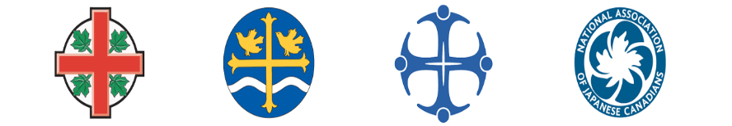

Project Office

All involved with the AHFJC funds must sign annual confidentiality agreements.
As of May, 2024
- Emi Lashin
- Liz Nunoda
- Ryan Walsh
Supported by
- Wendy Matsubuchi-Bremner
Facilitator/Project Manager
- Kevin Okabe,
NAJC Executive Director

Contact US

For confidential help, or for more details, contact Wendy:
jcworkinggroup@gmail.com
778-836-8250

Anglican Healing Fund for Japanese Canadians
c/o GVJCCA
6688 Southoaks Crescent
Burnaby, BC V5E 4M7

www.anglicanhealingfundfor japanesecanadians.com

Survivor:
“We are pleased that the crimes of Nakayama have been exposed. His name is still painful to me, but I am happy that I contributed to ending the silence.”

Survivor family member remarking on their AHFJC counselling: “This funding has been invaluable to my healing journey. I have actually been surprised at how much there is to process still, so again, thank you for this support.”

Survivor family member remarking on their AHFJC education grant:
“I was able to not only sustain my livelihood but also my educational pursuits. Without it, I think these would have been severely jeopardized.”

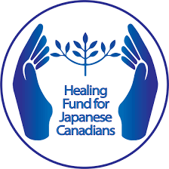

Addressing
clergy sexual abuse
by
Gordon Goichi Nakayama



Programme timeline:
Sept 2021-Sept 2026

