Daily church work log book

P18
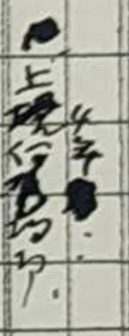
上堤仁も拘る（Kamisage jin sticks to something as well）or (We stick to embankment as well)
4年（four years）

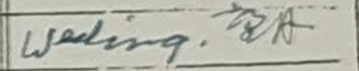
望月
Mochiduki

P19
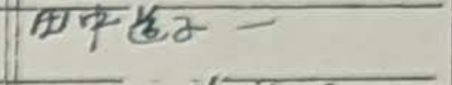
田中道子、(一)
Tanaka Michiko, (Hjime)
※（一） This might be just a dash mark to show the end of the sentence.

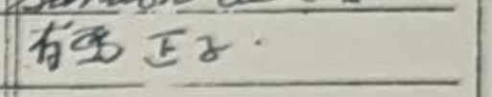
有馬正子
Arima Masako or Arima Shoko

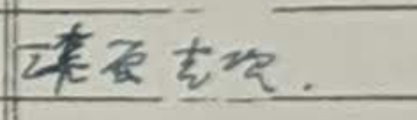
漆原克次
Urushibara Katsuji or Urushibara Katsutsugu

P20
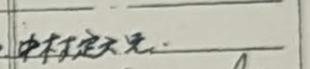
中村定文 兄
Nakamura Joubun Kei
Kei(兄) is an honorific title. Japanese people used it when they talked about someone older than they were to show their respect.
P21
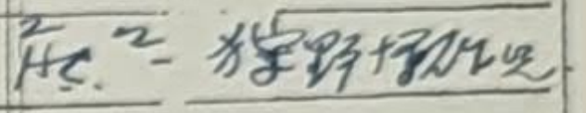
狩野伊作児 or 狩野伊佐児
Kano Isaji

P22
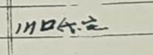
川口斤宅
Kawaguchi Kontaku or Kawaguchi Kon’s house or Mr.Kawaguchi’s house

P25
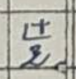
辻 兄
Tsuji kei

P27
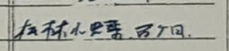
松林小蝶、五ヶ月
Matsubayashi Kocho, five months

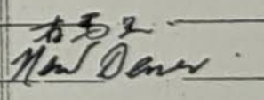
有馬 兄
Arima Kei

P28
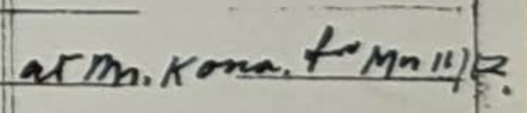
川口
Kawaguchi

P36
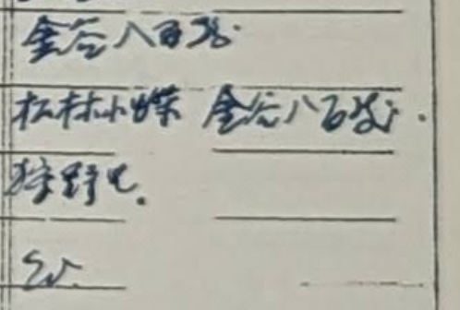
金谷八百屋 Kanaya Yaoya or 金谷八石 君 Kanaya Yaish kun
※Kun（君）is the polite way to call others. In these old times, they used it for people who were younger than they were.

松林小蝶(Matsubayashi Kocho), 金谷八石宅(Kanaya Yaishi’s house)
狩野 兄(Karino kei)

P37
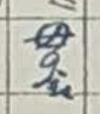
母の金 (mother’s money) or 毋の金(the money which can’t be used)

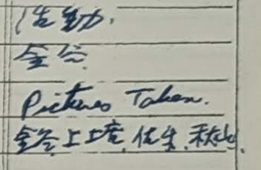
活動 Katudo （Activity）
金谷 Kanaya
金谷（Kanaya）、上塘(Kamidomo)、佐生(Saeki) or 佐尓(Saji)、秋山(Akiyama)

